Using Classpad II to plot piecewise defined function

Use your Classpad to plot the following piecewise defined function:

$$y= \left\{\begin{matrix}-2 x<-4 \\ 2x+6 -4≤x<4 \\ 14 x≥4\end{matrix}\right.$$

Step 1
Start by entering the piecewise template in y1 using the Math3 keyboard (tap it twice).

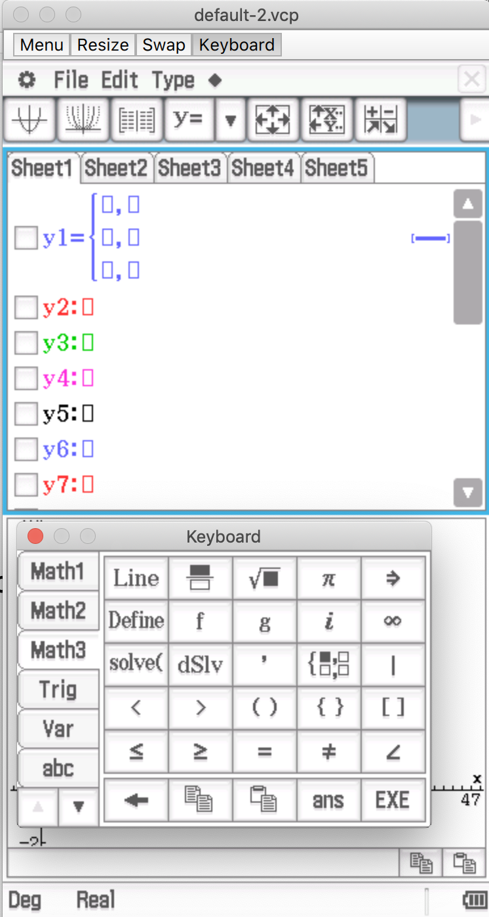

Step 2
Enter the functions, their domains and tap EXE.

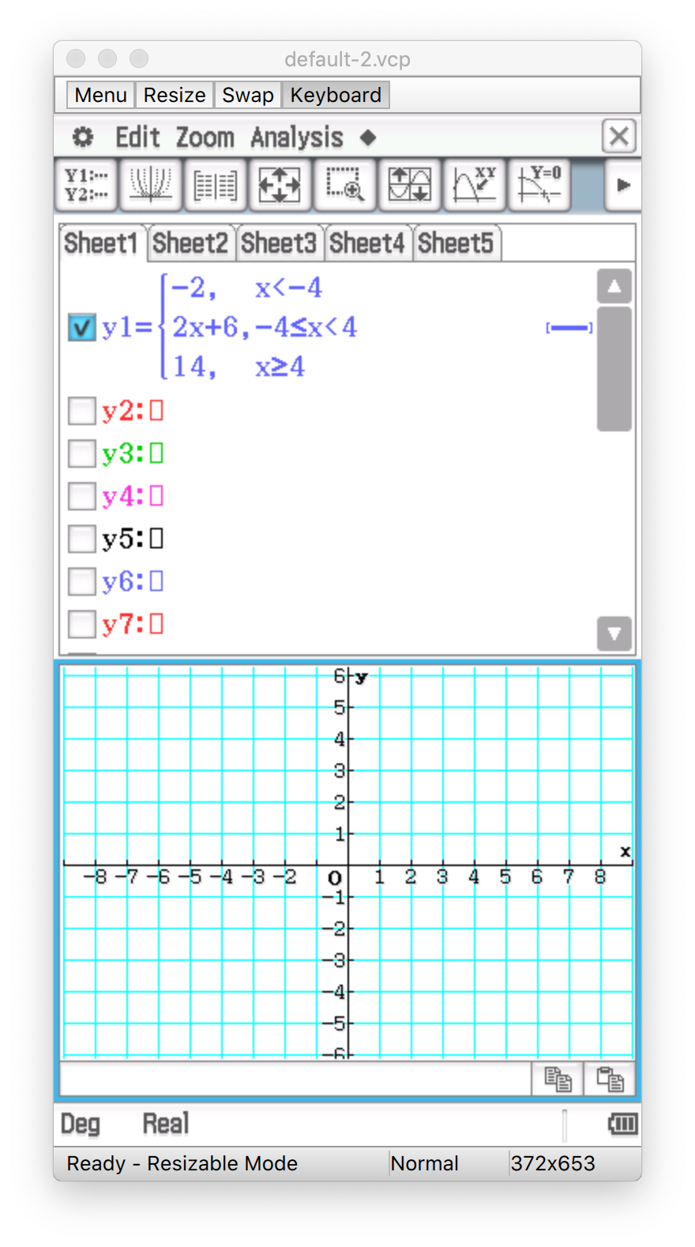

Step 3
Tap 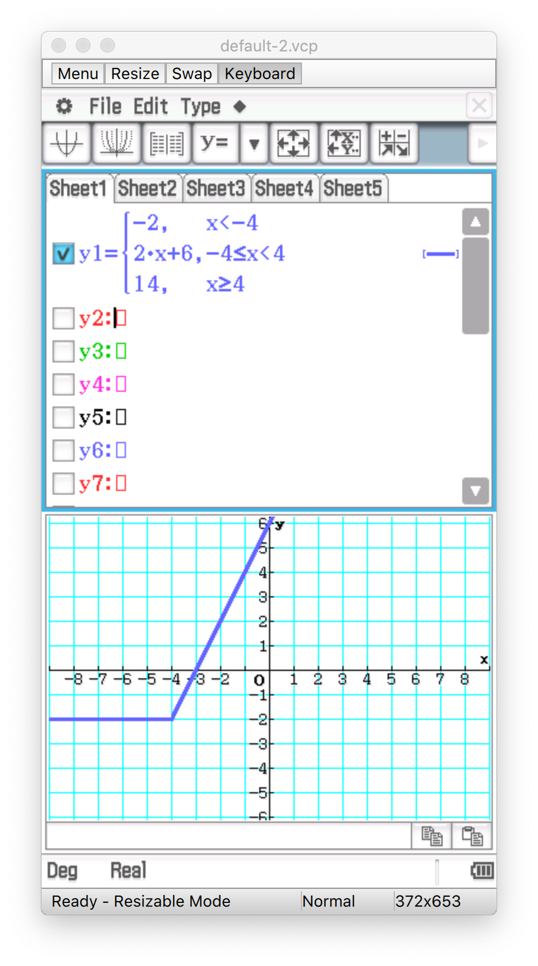.



Step 4
You can resize the graph to show the entire graph (you can use the zoom function as well).

